**BUS TRANSPORTATION SYSTEM  
HUMAN RESOURCE 2**A Project Study  
Presented to the IT Faculty  
Bestlink College of the Philippines  
Quezon City, PhilippinesIn Partial Fulfillment of the Requirements for the Subject  
Project Study 1By:

Almonte, Jefferson

Baquir, Mark

Beltran, Tom Cris

Berino, Majirel

Dela Torre, NelsonOctober 2018

1. **Project Background**

Provincial Bus Transportation Company is a business that provide a service to its customers by transporting people and packages from different destinations in the province through buses.

Human Resource 2 is a module of the Bus Transportation System Enterprise Resource System (EIS). Human Resource 2 is composed of Competency Management, Succession Planning, Learning Management, Training Management and Employee Self-Service.

Competency Management helps the organization in creating and defining the core, leadership and job. And also, identifies the required set of abilities and skills needed to enhance performance and achieve success.

Succession planning identifies and develops potential leaders that is able to succeed the outgoing and old leaders when the leaders leave, retire, or die. It also expands availability of experienced and capable employees that are able to take the accept these roles and responsibilities as it become vacant.

Learning Management is a process of arranging, disseminating and delivering learning materials, assignments, assessments, and track and calculate grades.

Training Management administers to the training curriculums, schedules, training delivery, grading, records and training history of the employees, and provides venues for the trainings whether in-house or public trainings or seminars.

Employee Self Service or ESS is a website-based system that provides the employees to access information; alter contact information, family members, and benefits.; and send request/s to the HR Managers and immediate Supervisor.

* 1. **Project Charter**

**1.1.1 Vision**

Human Resource 2 is committed to provide a system that will deliver a reliable data in determining the employee’s development and competency for the Provincial Bus Transportation company.

**1.1.2 Objectives**

* To administer, document, track, report and deliver educational requirements for the employees
* To monitor the employee that will undergo and is undergoing the training
* To determine the employee that shows excellence and dedication for the company
* To provide an avenue for the employees to navigate employee’s information with confidentiality, security and accessibility

**1.1.3 Project Size Estimate**

The project will take up to 8 months from July 2018 to March 2019 to complete and release to the market for full operation. The cost will be about 400 Thousand to 5 Thousand pesos including the compensation of the development team, licenses of the applications, Bus Transportation System, utilities and other expenses that will be needed in the development of the system.

**1.1.4 Project Complexity Estimate**

The Human Resource 2 project is based on the standard process of the Philippines and must comply with the new Data Privacy Law that will provide security to the personal information of the employees. And the system must be in line with whatever law may passed.

**1.1.5 Scope**

Human Resource 2 focuses on identifying the able employees to replace the old employees that may leave, retire, or die; create and identify the core of the employee leadership, job descriptions and qualifications, and competencies in the market; providing an avenue for employees to know the right thing to be learned about the company, job description and others; developing the employees by allowing the employees to experience the learnings and trainings that can be acquire into actual practice and providing seminars that will put the best out of the employees; and providing an avenue for the employees to have the request automated, and see other information through the ESS portal in the browser.

**1.1.6 Organization**

|  |  |  |
| --- | --- | --- |
| **ROLE** | **NAMES & CONTACT INFORMATION** | **RESPONSIBILITIES** |
| Project Owner | Dr. Rommel Constantino | * Serve as ultimate authority/ responsibility for the project * Provide strategic direction and guidance * Approve changes to scope * Identify and secure funding * Make business / approach decisions for the project * Participate in key activities * Make resources available * Approve work products, address issues, and approve change requests |
| Scrum Master | Nelson Dela Torre | * Report to and receive direction from sponsors * Manage, review, and prioritize project work plans * Provide status reports * Manage project team * Recommend changes, escalate issues, and mitigate risks |
| Development Team | Jefferson Almonte  Majirel Berino  Tom Cirs Beltran  Mark Baquir | * Participate in project activities, including planning, implementation of deliverables, and quality control |
| Stakeholders | Dr. Rommel Constantino  Mr.Jesryl Gondino  Mr.Leoned  Andrew Tumbaga | * Provide the idea to the research. |

**1.1.7 Resources**

* www.scholar.google.com
* https://www.unece.org/fileadmin/DAM/stats/publicati

ns/HR

MT_w_cover_resized.pdf

* https://www.hrpayrollsystems.net/employee-self-service/
* https://blog.commlabindia.com/elearning-development/learning-management-system-workflow
* http://www.cedma-europe.org/newsletter%20articles/LTI%20Mag/Understanding%20your%20Training%20Process%20(Sep%2005).pdf
* https://www.tbs-sct.gc.ca/gui/spgr/spg-gpgr-02-eng.asp?for=hrps
* https://blog.avilar.com/2017/11/20/integrating-a-competency-management-method-5-steps/

**1.1.8 Approach and Methodology**

Agile Scrum Methodology is a conceptual framework for undertaking software engineering projects. These are numbers of agile software development and sprint time box effort, is it restricted to a specific duration during each sprint, the team creates finished portion of a product.

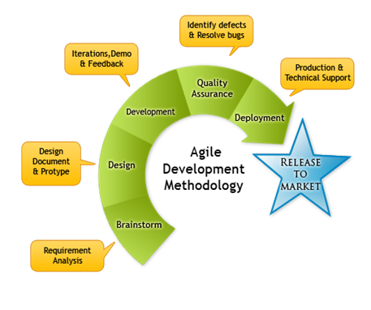

**Brainstorm**

Brainstorming is a team creativity and analytical technique by which efforts are made to find solution for a specific problem by gathering a list of ideas spontaneously contributed by its members.

**Design**

The creation of a plan or convention for the construction of an object, system or measurable human interaction Like business process, circuit diagram and serving patterns.

**Development**

A systematic use of scientific and technical knowledge to meet specific requirements.

**Quality Assurance**

Way of preventing mistake and defects in manufactured products and Avoiding problems When delivering solutions or services to Customers.

**Deployment**

Methodical procedures of introducing an Activity, Price, Program, Or system to all applicable areas of an organization.

**1.1.9 Success Criteria**

The following are the determining factors in considering that the finished subsystem of Human Resource 2 is a success,

* Integration of the data between the subsystems
* Completion date should be on the second week of February, 2019 or earlier the date indicated.
* Daily meeting with the development team with the questions
  + What are the challenges you encountered?
  + What did you do yesterday?
  + What will you do today?
* Once a month meeting or if necessary meeting with the project owner and stakeholders for additional inputs
* Completion of the project sprints and backlogs on the before the deadlines.
* Real-time update on what is going on with the system for the project owner
* Real-time update on the task completed by the development team for the project owner
* Can generate reports
* Produce Accurate dashboard data

**1.1.10 Priorities**

* Access levels for every user
* Account creation or registration for new system user
* Accurate dashboard with the database
* Generates graphs for each submodule and module
* Generates reports
* Reports saved to PDF format including the graphs
* Data integration

**1.1.11 Product Roadmap**

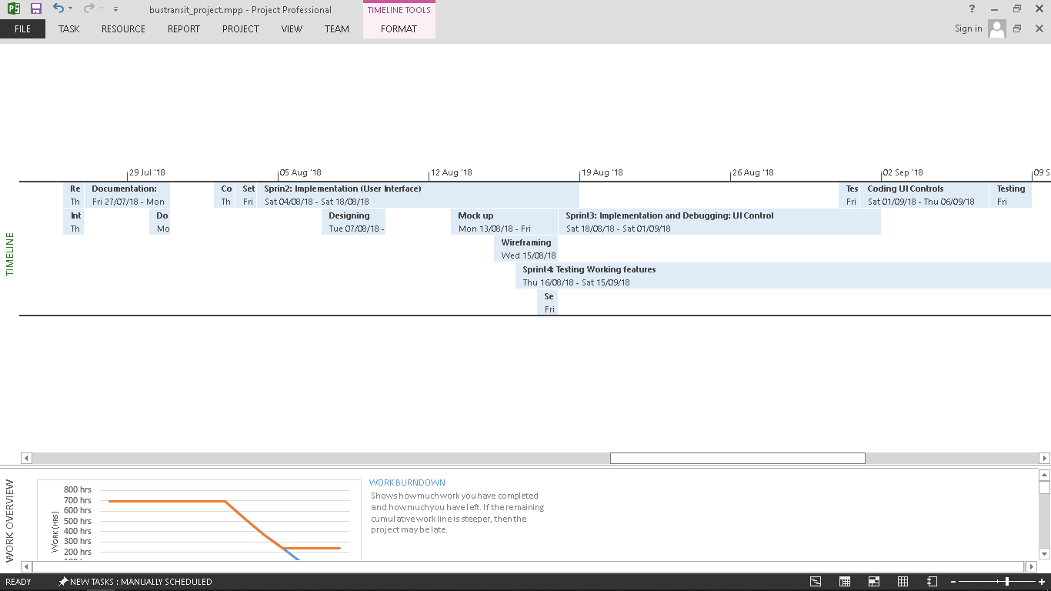

**1.1.12 Assumptions and Constraints**

All of the assumptions in the creation of the system, but being limited by other factors that will greatly affect the system.

|  |  |
| --- | --- |
| **Assumptions** | **Constraints** |
| Twice a week consultation with the Project Owner/ Adviser | Full workload of the Project Owner/ Adviser |
| Project to be completed within two semesters | New methodology |
| Weekly meeting with the development team | Many class cancellations due to the weather |
| Great help from the Project Owner / Adviser | New Instructor to be the Project Owner/ Adviser |
| Document to have basis on the content to be inserted. | No available copy of the new document with complete content |

**1.1.13 Risks and Issues**

|  |  |  |  |
| --- | --- | --- | --- |
| **Risk Factors** | **Probability**  **(H-M-L)** | **Impact**  **(H-M-L)** | **Risk Management**  **Action** |
| Technical Risk | H | H | Prepare backups in that will compensate with the technical risk |
| Calamity Risk | H | M | Complete planning of the task needed for the completion of the system. |
| Security Risk | M | L | Strengthening the security features that will only authorize the right person to use the system. |
| Financial Risk | M | M | We decide to manage our income properly, so that we will not become short in terms of money. |
| User Risk | L | L | Provide user manual or video tutorial. To prevent error while using the system give a guide or instruction how proper use the system. |

**1.1.14 Sign-off**

Monthly Maintenance – To keep the system safety standards

Seminar – To get some ideas on how the system works.

Users – experts that can handle the actual system.

* 1. **Project Plan**

Provincial Bus Transportation System development will improve the integration and processes of the business. It also will help the employee’s workload through the system and website that will also cater the needs of the its customers.

The development duration of the system will take up to 8 months from July 2018 to March 2019 to complete and be available to be release to the market for the use of the business and will amount to 3 Million to 5 Million estimated cost for the overall development of the system.

|  |  |  |  |  |
| --- | --- | --- | --- | --- |
| Task Name | Duration | Start | Finish | Resource Names |
| **Sprint1: Planning, Information Gathering and Project Setup** | **12 days** | **Thu 19/07/18** | **Fri 03/08/18** |  |
| Initial Research about Project | 2 days | Fri 20/07/18 | Sat 21/07/18 | Dela Torre Nelson M,  Almonte Jefferson,  Baquir Mark,  Beltran Tom Cris,  Berino Majirel |
| Planning Project file Structure | 1 day | Mon 23/07/18 | Mon 23/07/18 | Dela Torre Nelson M |
| Set up Project in NetBeans | 1 day | Mon 23/07/18 | Tue 24/07/18 | Dela Torre Nelson M |
| Resource Planning | 1 day | Thu 26/07/18 | Thu 26/07/18 | Dela Torre Nelson |
| Integration Planning | 1 day | Thu 26/07/18 | Fri 27/07/18 | Dela Torre Nelson,  Almonte Jefferson,  Baquir Mark,  Beltran Tom Cris,  Berino Majirel |
| Documentation: Creating Project Charter | 2 days | Fri 27/07/18 | Mon 30/07/18 | Beltran Tom Cris  Baquir Mark,  Berino Majirel |
| Documentation: Gathering User stories | 1 day | Mon 30/07/18 | Tue 31/07/18 | Dela Torre Nelson,  Almonte Jefferson,  Baquir Mark,  Beltran Tom Cris,  Berino Majirel |
| Complementary Research for modules | 1 day | Thu 02/08/18 | Thu 02/08/18 | Dela Torre Nelson,  Almonte Jefferson,  Baquir Mark,  Beltran Tom Cris,  Berino Majirel |
| Set up database: MySQL | 1 day | Fri 20/04/18 | Fri 20/04/18 | Baquir Mark |
| Set up Web site | 1 day | Fri 03/08/18 | Fri 03/08/18 | Dela Torre Nelson |
| **Sprin2: Implementation (User Interface)** | **12 days** | **Sat 04/08/18** | **Sat 18/08/18** |  |
| Wireframing | 3 days | Wed 15/08/18 | Fri 17/08/18 | Almonte Jefferson,  Dela Torre Nelson |
| Mock up | 5 days | Mon 13/08/18 | Fri 17/08/18 | Almonte Jefferson,  Dela Torre Nelson |
| Searching UI Frameworks | 1 day | Fri 17/08/18 | Fri 17/08/18 | Dela Torre Nelson M |
| Designing Modular Components | 3 days | Tue 07/08/18 | Thu 09/08/18 | Almonte Jefferson,  Dela Torre Nelson M |
| **Sprint3: Implementation and Debugging: UI Control** | **12 days** | **Sat 18/08/18** | **Sat 01/09/18** |  |
| Testing Frame Transitions | 1 day | Fri 31/08/18 | Fri 31/08/18 | Almonte Jefferson,  Dela Torre Nelson M |
| Coding UI Controls | 5 days | Sat 01/09/18 | Thu 06/09/18 | Almonte Jefferson,  Dela Torre Nelson M |
| Testing UI Controls with data fetching | 2 days | Fri 07/09/18 | Sat 08/09/18 | Almonte Jefferson,  Beltran Tom Cris,  Dela Torre Nelson M |
| Reviewing Queries and Testing working features | 4 days | Sun 09/09/18 | Wed 12/09/18 | Dela Torre Nelson, Almonte Jefferson,  Beltran Tom Cris |

* 1. **System Architecture**

Small picture

|  |  |
| --- | --- |
| Business Process Architecture | **https://lh6.googleusercontent.com/U7beQNB_i-Hs0qNSqfxBmIVpLNmhcrG6eGJW_6TFDymyI4JBf2PPZ9wbkEiXBVhOvKw5g0ho2Ij_7Fxd7zNOHdn5rSZacjI-hVD_1_0wzOFoi3iYjjXy8jTu3v2Irpu9BMG9VdoE** |
| Application Architecture |  |
| DateArchitecture | **https://lh3.googleusercontent.com/xRUMaY9Ru9O6lPaGzAuxSuO7myVKsUN-ap3ANjHZmo7ZVyXlUbNWTiyj2gTJ89t-W_MLm2vJGgmZ1NAqodcqcv4xvi0QYAI1lv9JMqYE-_9kxbr-YTM7GTR_uOJJaoD-3IZvoi8R_YdqPdc39w** |
| Technology Architecture |  |

* + 1. **Business Process Architecture**

Diagram that shows the procedures done in the business in order to attain a successful transaction and activity of the company.

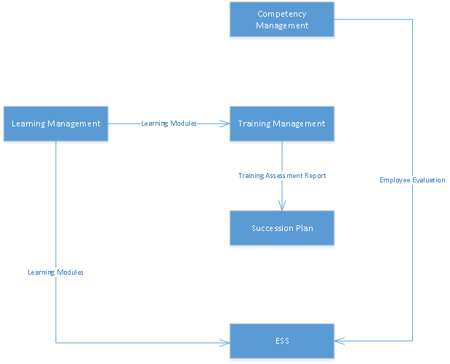

* + 1. **Application Architecture**

Diagram that provides the walkthrough of the system on what are the steps or processes in using the system.

* + 1. **Data Architecture**

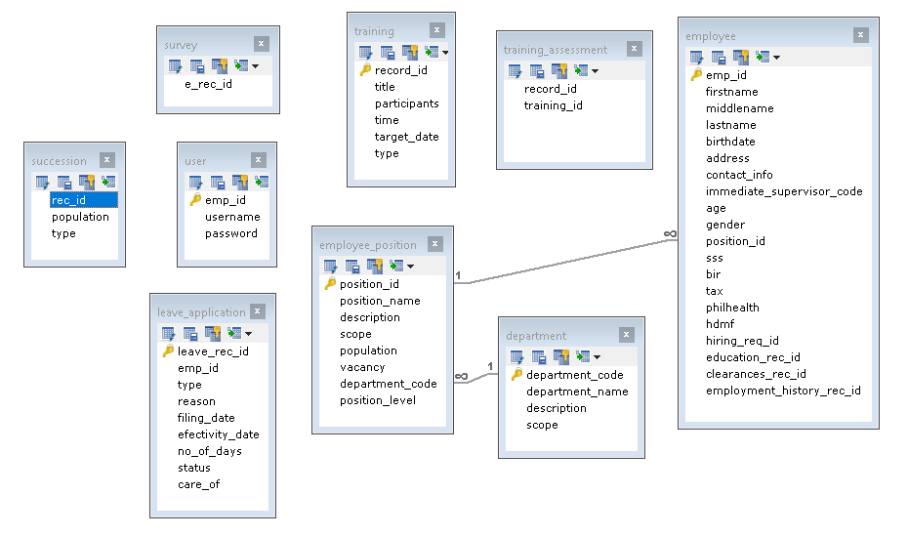 Entity Relationship Diagram for the Human Resource 2 on how the integration of the data happens

* + 1. **Technology Architecture**

Logos of the applications, softwares, and hardware used in the development of the system.



1. **Product Backlog**

2.1 Product Backlog (User Stories) Table

|  |  |  |  |  |  |
| --- | --- | --- | --- | --- | --- |
| User Story Number | User Stories | User Story Priorities | Requirement Reference | Revised Priority | Status |
| 1 | As an employee, I want to be able to send my leave request online. So that, I am assured that the request is being read by the HR Officers | 1 | Employee |  | On- going |
| 2 | As an employee, I want to see my working schedule online. So that, I am updated immediately whenever changes arise | 2 | Employee |  | Pending |
| 5 | As an HR Officer, I want to have the scores of the applicants or employees be computed automatically. So that, I will lessen the time consumed in checking the exam. | 5 | HR Officer |  | Pending |
| 7 | As an HR Officer, I want to disseminate the learning modules online. So that, the employees and applicants will no longer have the hassle in getting the learning modules from the HR department. | 7 | HR Officer |  | Pending |
| 8 | As an employee, I want to have the learning module to be downloadable. So that, it will be viewable everywhere without using the internet. | 8 | Employee |  | Pending |
| 9 | As an HR Officer, I want to be able to view the progress of the applicants and employees. So that, I will no longer run through individual paper records in order to see their progress. | 9 | HR Officer |  | Pending |
| 10 | As an HR Officer, I want to automatically provide the qualifications needed in a job position. So that, we will be able to have the standard qualifications for every job position. | 10 | HR Officer |  | Pending |
| 11 | As an HR Officer, I want to have automatically search the list of people qualified for an open job position in the company. So that, I will no longer hassle on going through the employee's information. | 11 | HR Officer |  | Pending |
| 12 | As an HR Officer, I want to have the list of the public and in-house seminars and trainings be viewed in the system. So that, no trainings and seminars will be left out. | 12 | HR Officer |  | On-going |
| 13 | As an employee, I want to see the required seminars and trainings I need to take. So that, I will have it be planned out. | 13 | Employee |  |  |
| 14 | As an HR Officer, I want to select employees to be sent out in public seminars and trainings and be put into a list. So that, there will be an easy way of selecting employees. | 14 | HR Officer |  |  |
| 15 |  | 15 |  |  |  |

2.2 Product Backlog for EIS Information Security

|  |  |  |  |  |  |
| --- | --- | --- | --- | --- | --- |
| User Story Number | User Stories | User Story Priorities | Requirement Reference | Revised Priority | Status |
| 1 | As an Employee I want to be the only person to view my personal information aside from the people managing it. So that, I am sure that my information is secured | 1 | Employee |  |  |
| 2 | As an HR Manager, I want to have a login access in the system. So that, the employees will know the scope of their jobs. | 2 | HR Manager |  |  |
| 3 | As an HR Manager, I want to generate data that will be a graphical report. So, that I can easily analyze the data I only need to analyze. | 3 | HR Manager |  |  |
| 4 | As an HR Manager, I want to view the graphical report of the HR 2. So that, I can easily analyze the data. | 4 | HR Officer |  |  |
| 5 | As an HR Manager, I want to print out the generated reports. So that, it could be stored and be used in the future | 5 | HR Manager |  |  |

2.3 Product Backlog for EIS Standards

In order to create an organized system interface, the development team created a template that does create uniformity in the system design or interface.

2.3.1 UI/UX (icons, color, etc.)

* UI – Material Design

    Material Design is a visual language that synthesizes the classic principles of good design with the innovation of technology and science.

Source: https://material.io/design/introduction/

* Icons – Fontawesome 8.9

    Font Awesome is a font and icon toolkit based on CSS and LESS. It was made by Dave Gandy for use with Twitter Bootstrap, and later was incorporated into the BootstrapCDN.

* Font

o   Font Family - Calibri

o   Main Text – 14dp

o   Heading text – 18dp

o   Body text – 14dp

o   Footer text – 12dp

* Color Palate

o   Default Button- (Blue) #0078D7

o   Success Button – (Green) #43a047

o   Cancel Button – (Red) #f44336

o   Warning – (Orange) #ff5722

o   Links – (Light Blue)  #03a9f4

2.3.2 Messages

* Button Label – Calibri, 12dp inside Tooltip
* JFXDialog Heading – Calibri, 18dp
* JFXDialog Body Text – Calibri, 14dp
* Input Dialog uses JFXTextField

2.3.3 Database

* bustransit_master database file

Master database that developer team should use to integrate systems.

* bustransit_online database file

Sub set of bustransit_master that is use for online rendering of data.

* bustransit_archive database file

Archive storage and replication of Master database, used to store archive records.

* DBUtilities.java

Java file database utility system use by the team during development.

2.4 Product Backlog for Integration

* Centralized Login System

By creating one login system for the project, sub system will integrate in terms of access level and user control as long as the design of the project.

* One Project file Structuring

In order to integrate and control file accessibility within the project, standardized file structuring should be followed, development team should use MVC file structure.

* Standardized Database Architecture

Developer team should collaborate during creation and development of database structure to normalize and reduce table and data redundancy.

2.5 Product Backlog for Analytics

2.5.1 Application System Analytics

* Native JavaFX Charts

Development team should use only JavaFX native charts for data visualization; it can be Pie Charts, Bar Charts, Line Charts and Stack Area Charts depending on the needs.

* Modular dashboard

On quick access to data visualizations and important information, sub systems should provide modular dashboard where are the summary of information among modules are displayed.

2.5.2 EIS Analytics

* Pie Chart

Should only use if in need of data visualization for the project which is part of the whole.

* Bar Chart

Developers should only use Bar Chart if comparing entities over trends.

* Line Chart

Use Line Chart if in need for visualizing data of a trend over a given time period, for example by week, by month or by year.

* Stacked Area Chart

Similar to Line Chart but with additional area view for the trend or changes over time.

**Chapter 3**

**SPRINT BACKLOG**

**3.1 Sprint Backlog Table**

**3.1.1 User Stories**

|  |  |  |  |  |
| --- | --- | --- | --- | --- |
| **User Story Number** | **User Stories** | **Tasks**  **(1…..n)** | **User Story Points** | **Responsible Team Member** |
| 1 | As an employee, I want to be able to send my leave request online. So that, I am assured that the request is being read by the HR Officers | 1 | 1 | Jefferson Almonte |

|  |  |  |  |  |
| --- | --- | --- | --- | --- |
| 12 | As an HR Officer, I want to have the list of the public and in-house seminars and trainings be viewed in the system. So that, no trainings and seminars will be left out. | 1 | 12 | Dela torre, Nelson |
|  |  |  |  |  |
|  |  |  |  |  |
|  |  |  |  |  |
|  |  |  |  |  |
|  |  |  |  |  |

**3.1.2 Information Security**

|  |  |  |  |  |
| --- | --- | --- | --- | --- |
| **IS Number** | **IS Description** | **Tasks**  **(1…..n)** | **IS Points** | **Responsible Team Member** |
|  |  |  |  |  |
|  |  |  |  |  |
|  |  |  |  |  |
|  |  |  |  |  |
|  |  |  |  |  |
|  |  |  |  |  |
|  |  |  |  |  |

**3.1.3 EIS Standards**

|  |  |  |  |  |
| --- | --- | --- | --- | --- |
| **Standard Number** | **Standard Description** | **Tasks**  **(1….n)** | **EIS Standards Points** | **Responsible Team Member** |
|  |  |  |  |  |
|  |  |  |  |  |
|  |  |  |  |  |
|  |  |  |  |  |
|  |  |  |  |  |
|  |  |  |  |  |
|  |  |  |  |  |

**3.1.4 EIS Integration**

|  |  |  |  |  |
| --- | --- | --- | --- | --- |
| **Integration Number** | **Integration Description** | **Tasks**  **(1….n)** | **Integration Standards Points** | **Responsible Team Member** |
|  |  |  |  |  |
|  |  |  |  |  |
|  |  |  |  |  |
|  |  |  |  |  |
|  |  |  |  |  |
|  |  |  |  |  |
|  |  |  |  |  |

**3.1.5 EIS Analytics**

|  |  |  |  |  |
| --- | --- | --- | --- | --- |
| **Analytics Number** | **Analytics Description** | **Tasks**  **(1….n)** | **Analytics Standards Points** | **Responsible Team Member** |
|  |  |  |  |  |
|  |  |  |  |  |
|  |  |  |  |  |
|  |  |  |  |  |
|  |  |  |  |  |
|  |  |  |  |  |
|  |  |  |  |  |
|  |  |  |  |  |
|  |  |  |  |  |
|  |  |  |  |  |
|  |  |  |  |  |
|  |  |  |  |  |
|  |  |  |  |  |
|  |  |  |  |  |
|  |  |  |  |  |
|  |  |  |  |  |
|  |  |  |  |  |
|  |  |  |  |  |
|  |  |  |  |  |
|  |  |  |  |  |
|  |  |  |  |  |

**3.2 Sprint Burndown Chart (Signed by Product Owner)**

|  |  |  |  |  |  |  |  |
| --- | --- | --- | --- | --- | --- | --- | --- |
| **Sprint 1 Backlog** | | | **Sprint 1 (2 Weeks)** | | | | |
| **Product**  **Backlog Item ID** | **User Stories**  **(Features)** | **Initial**  **Estimate** | **Day 1** | **Day 2** | **Day 3** | **Day 4** | **Day 14** |
|  |  |  |  |  |  |  |  |
|  |  |  |  |  |  |  |  |
|  |  |  |  |  |  |  |  |
|  |  |  |  |  |  |  |  |
|  |  |  |  |  |  |  |  |
|  |  |  |  |  |  |  |  |
|  |  |  |  |  |  |  |  |
|  |  |  |  |  |  |  |  |
|  | **Total Effort** | **80** | **70** | **60** | **50** | **30** | **10** |
|  |  |  |  |  |  |  |  |
| **Sprint Burndown Chart** | | | | | | | |

|  |  |  |  |  |  |  |  |
| --- | --- | --- | --- | --- | --- | --- | --- |
| **Sprint 2 Backlog** | | | **Sprint 2 (2 Weeks)** | | | | |
| **Product**  **Backlog Item ID** | **User Stories**  **(Features)** | **Initial**  **Estimate** | **Day 1** | **Day 2** | **Day 3** | **Day 4** | **Day 14** |
|  |  |  |  |  |  |  |  |
|  |  |  |  |  |  |  |  |
|  |  |  |  |  |  |  |  |
|  |  |  |  |  |  |  |  |
|  |  |  |  |  |  |  |  |
|  |  |  |  |  |  |  |  |
|  |  |  |  |  |  |  |  |
|  |  |  |  |  |  |  |  |
|  | **Total Effort** | **90** | **70** | **40** | **30** | **20** | **5** |
|  |  |  |  |  |  |  |  |
| **Sprint Burndown Chart** | | | | | | | |

**3.3 Sprint Backlog Output**

|  |  |  |  |  |
| --- | --- | --- | --- | --- |
| **Task Number** | **Task Name** | **Output** | **Test Result** | **Accepted by Product Owner** |
|  |  |  |  |  |
|  |  |  |  |  |
|  |  |  |  |  |
|  |  |  |  |  |
|  |  |  |  |  |
|  |  |  |  |  |
|  |  |  |  |  |
|  |  |  |  |  |
|  |  |  |  |  |
|  |  |  |  |  |
|  |  |  |  |  |
|  |  |  |  |  |
|  |  |  |  |  |
|  |  |  |  |  |
|  |  |  |  |  |
|  |  |  |  |  |
|  |  |  |  |  |
|  |  |  |  |  |
|  |  |  |  |  |
|  |  |  |  |  |
|  |  |  |  |  |

Chapter 4

User Manual